#### **1** [**DataStory: Explain Data and Inspire Action Through Story**](https://www.amazon.com/DataStory-Explain-Inspire-Action-Through/dp/1940858984) **- Nancy Duarte**

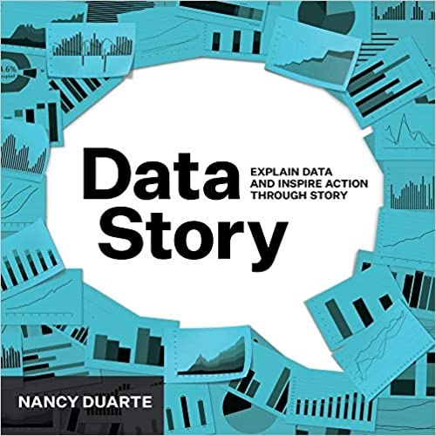

#### 

#### **﻿﻿**

2 [**Storytelling with Data: A Data Visualization Guide for Business Professionals**](https://www.amazon.com/Storytelling-Data-Visualization-Business-Professionals/dp/1119002257)- Cole Nussbaumer Knaflic

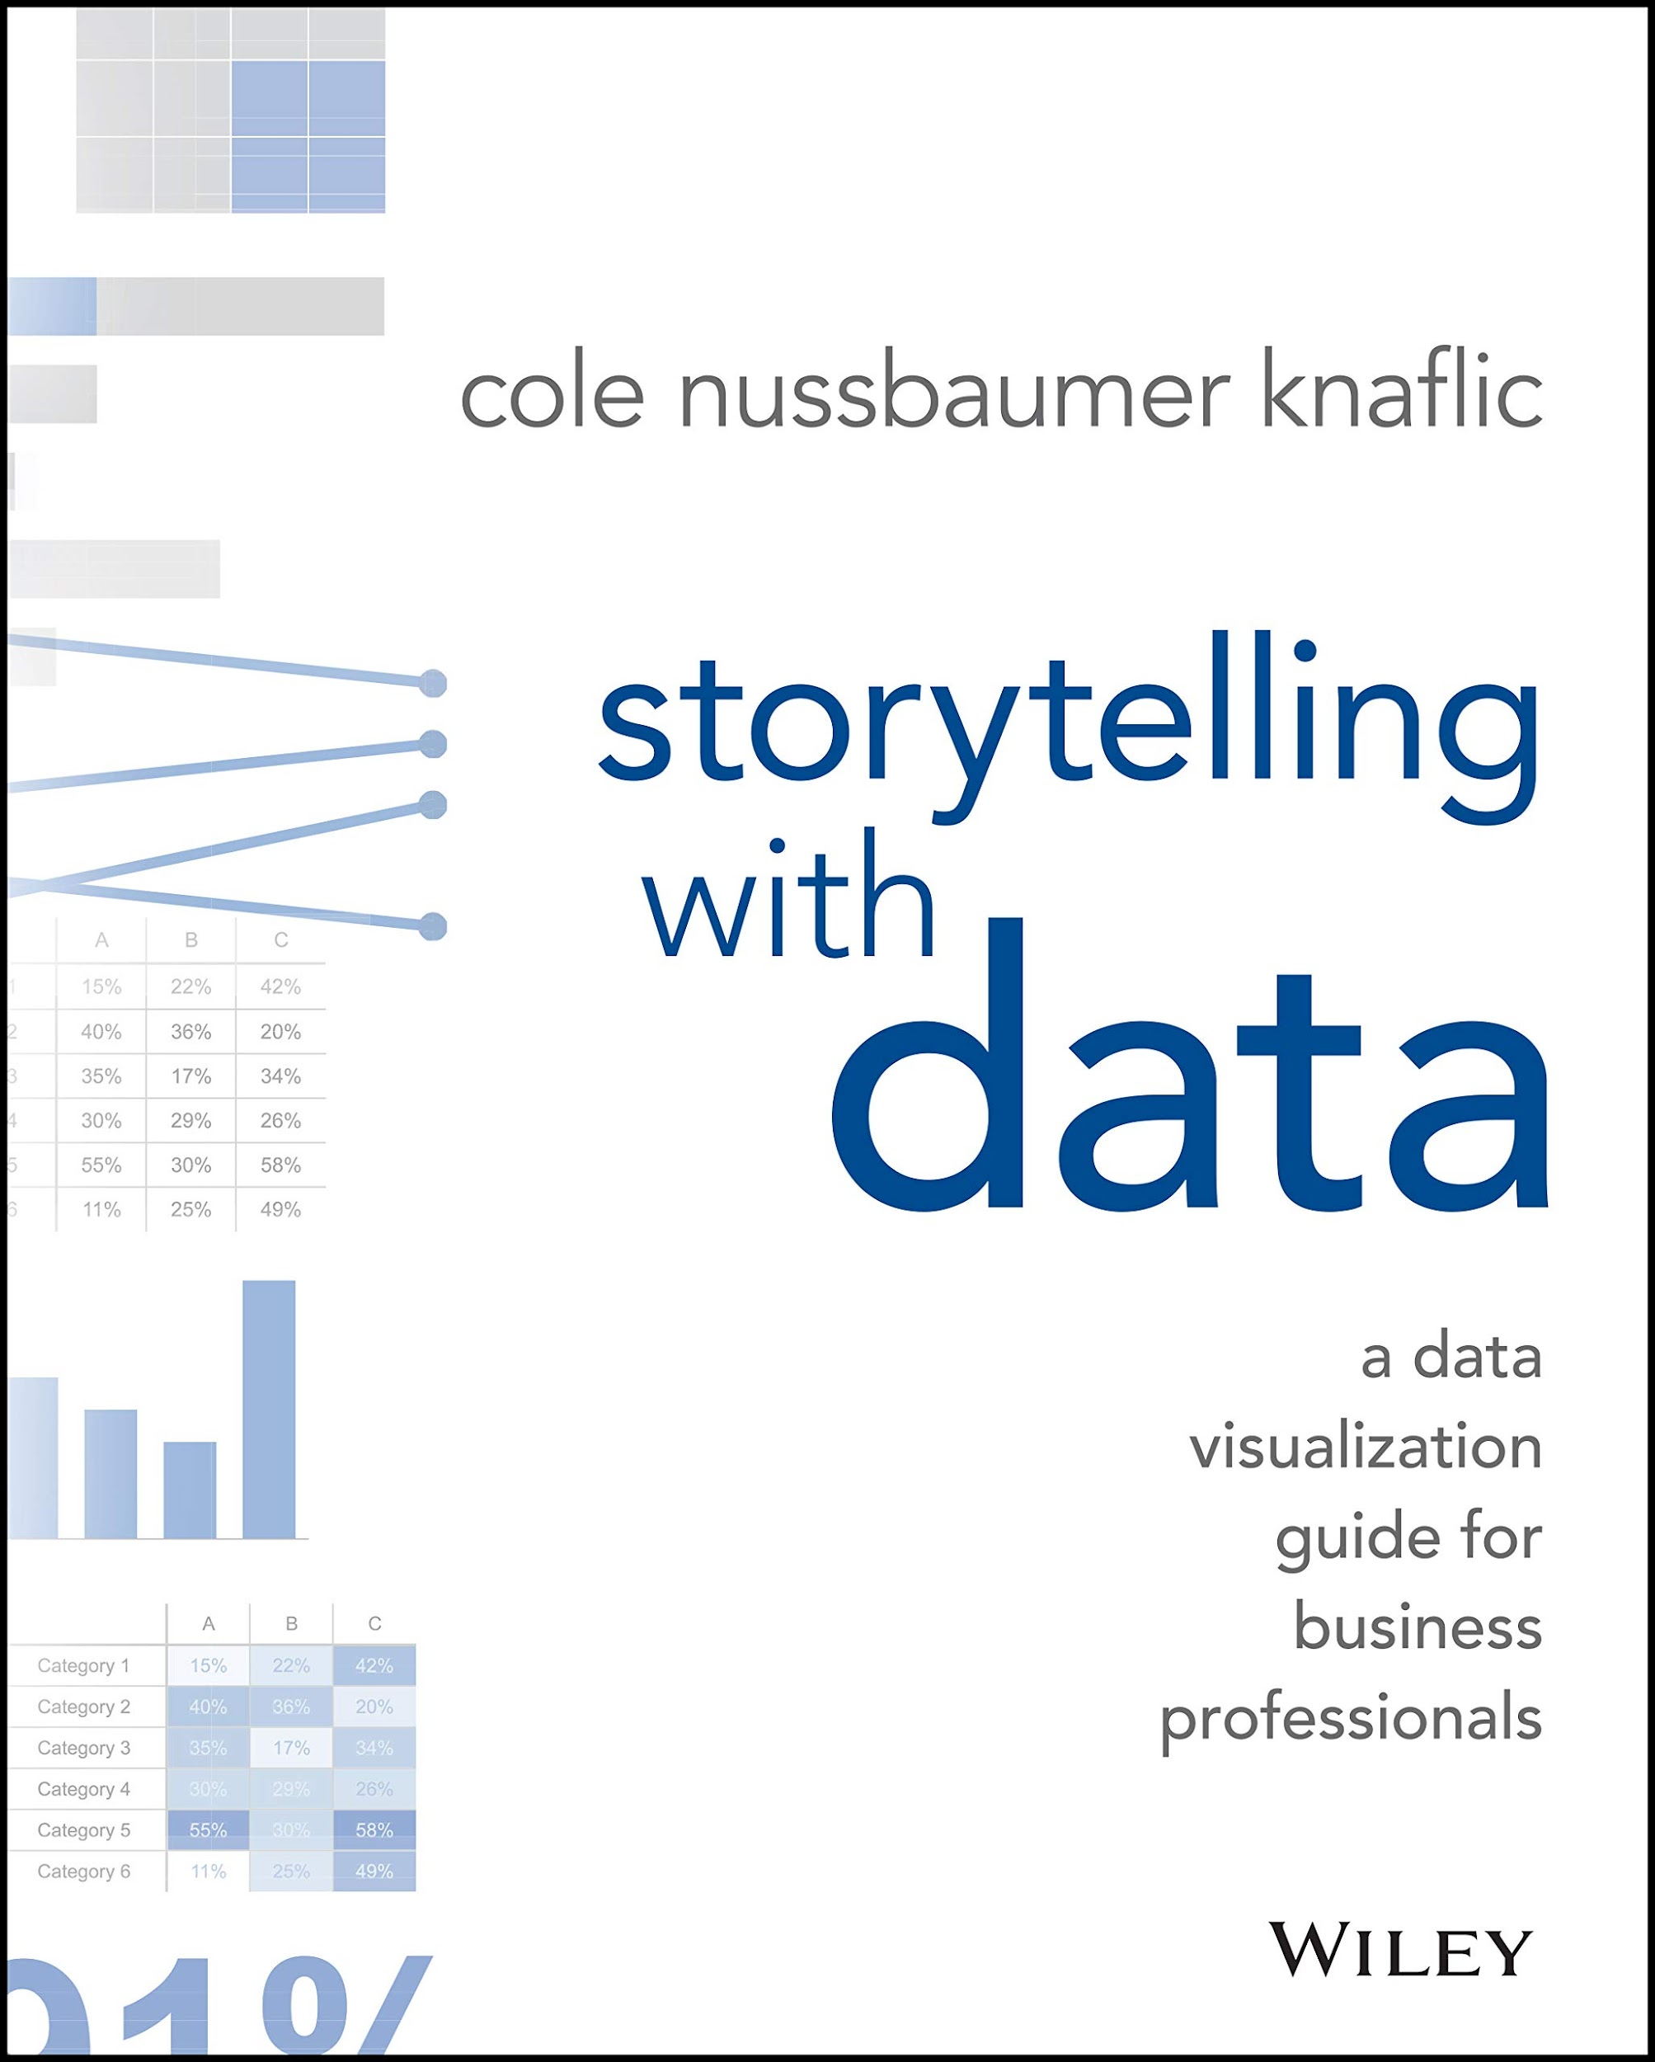

﻿﻿

3 [**The Visual Display of Quantitative Information**](https://www.amazon.com/Visual-Display-Quantitative-Information/dp/1930824130)- Edward R. Tufte

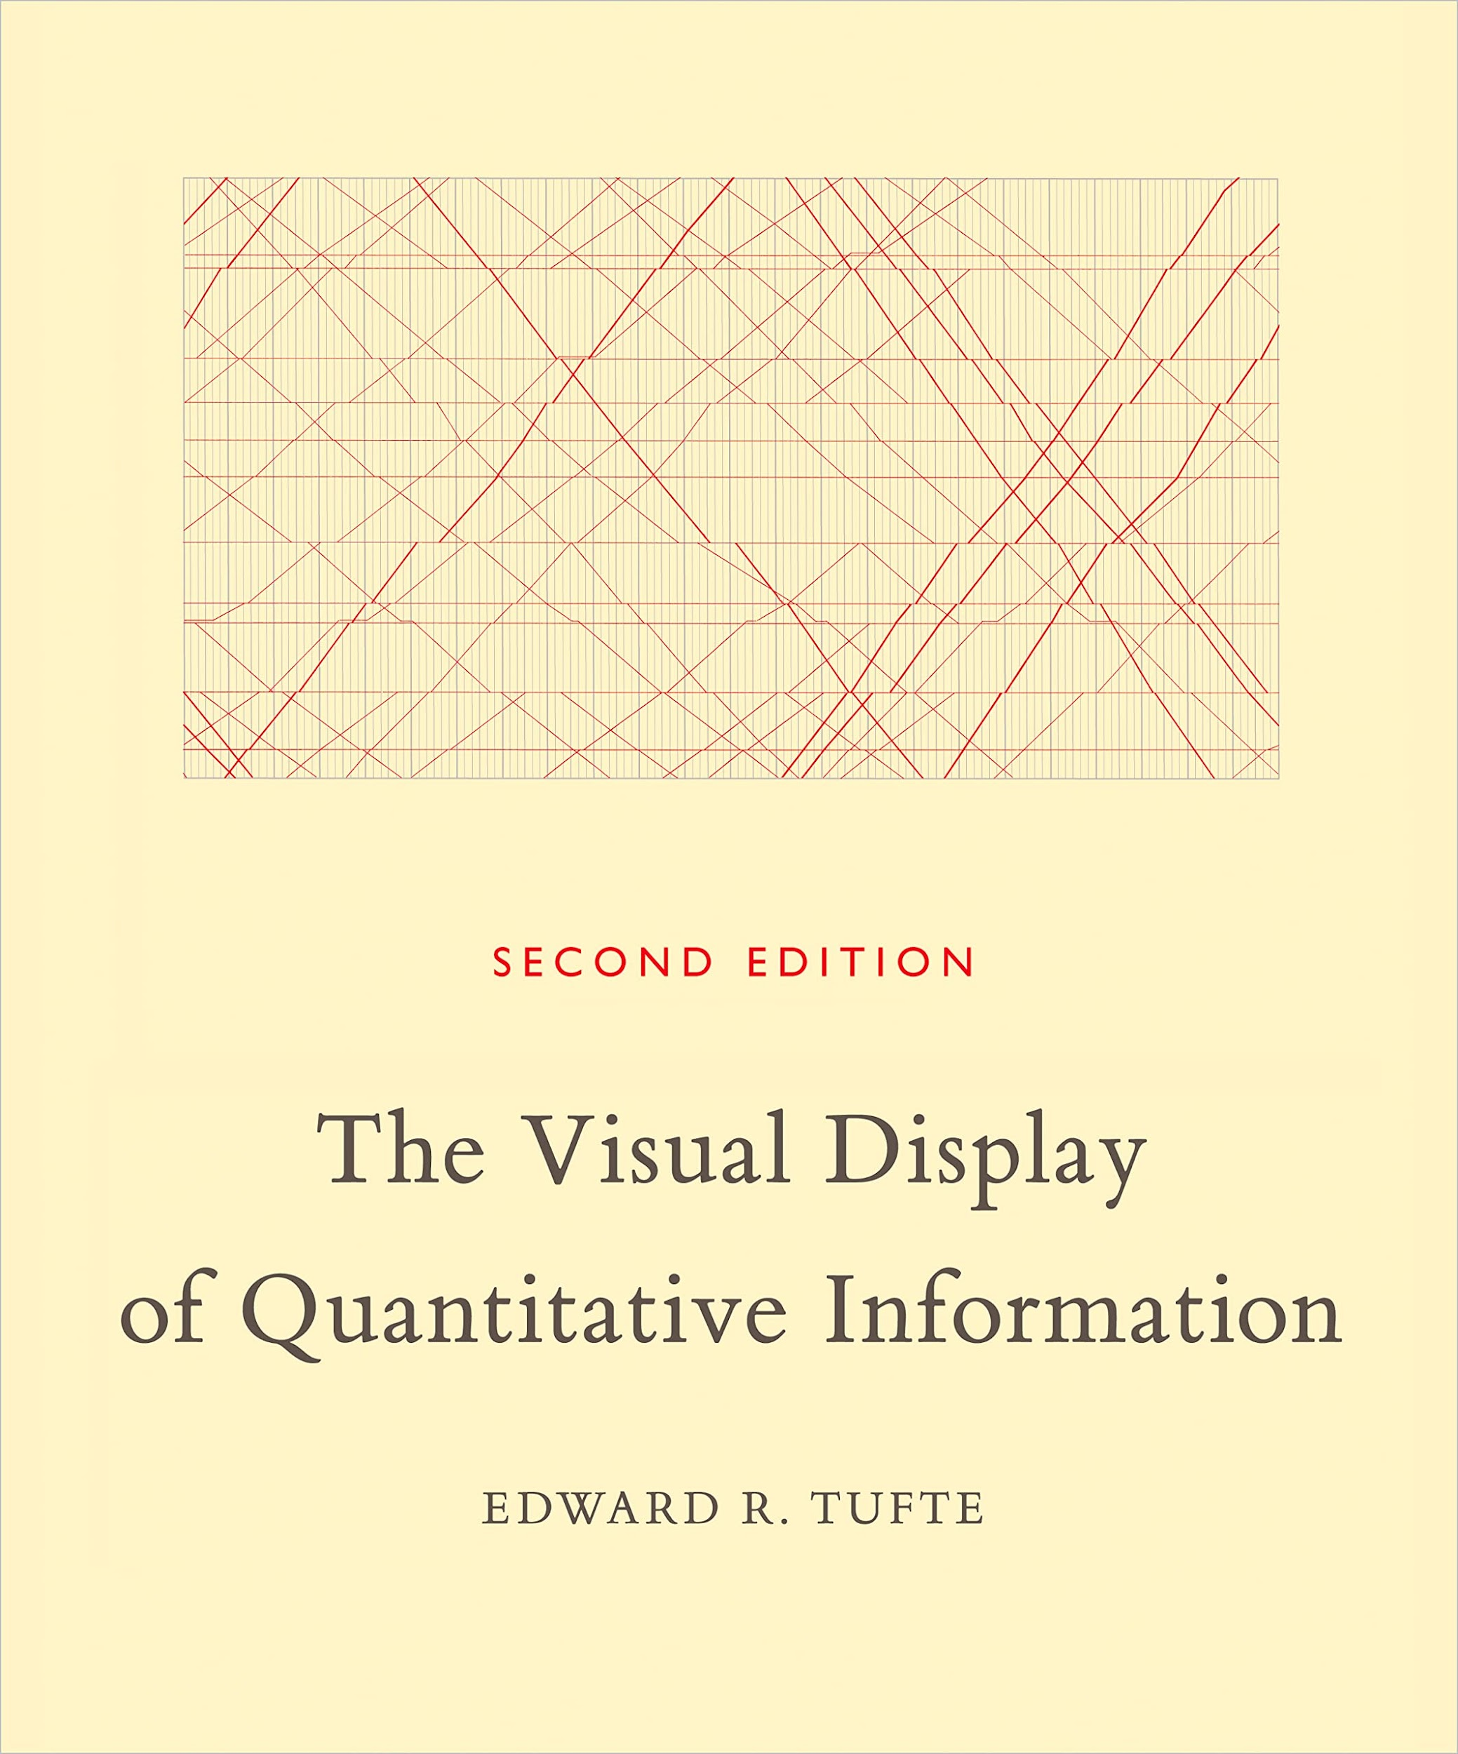

﻿﻿

4 [**Storyworthy: Engage, Teach, Persuade, and Change Your Life through the Power of Storytelling**](https://www.amazon.com/Storyworthy-Engage-Persuade-through-Storytelling/dp/1608685489)- Matthew Dicks

  
  
